Name: _____________________________
Cut out the words in the box and put them under the word they rhyme with, there is an extra space in each column in case you think of other rhyming words.
 | 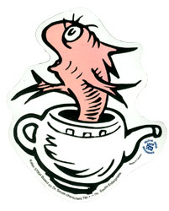
hat | fish | ball

call | fall | wall | tall
cat | mat | splat | pat
dish | squish | wish | swish

